**WITH NOISE AND WITHOUT FILTER**

**Image set:**

|  |
| --- |
| **Image 1:-0.1 % Noise** |

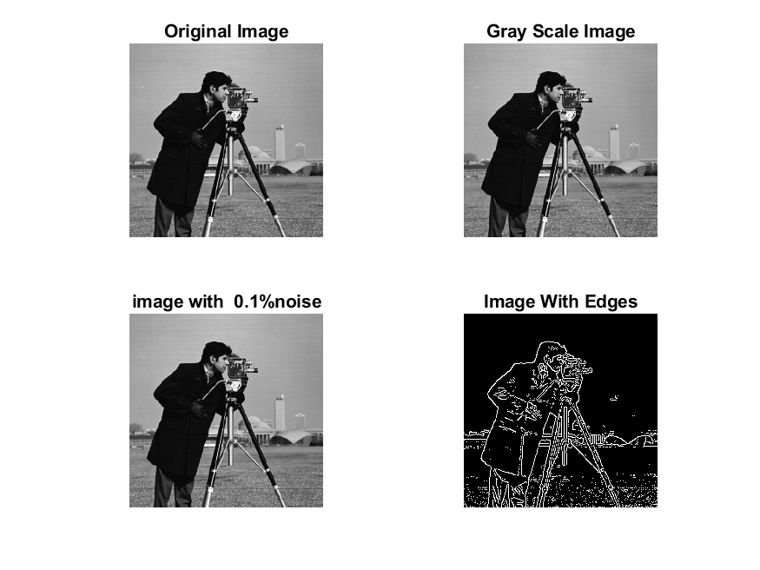

**Image 2:-10 % Noise**

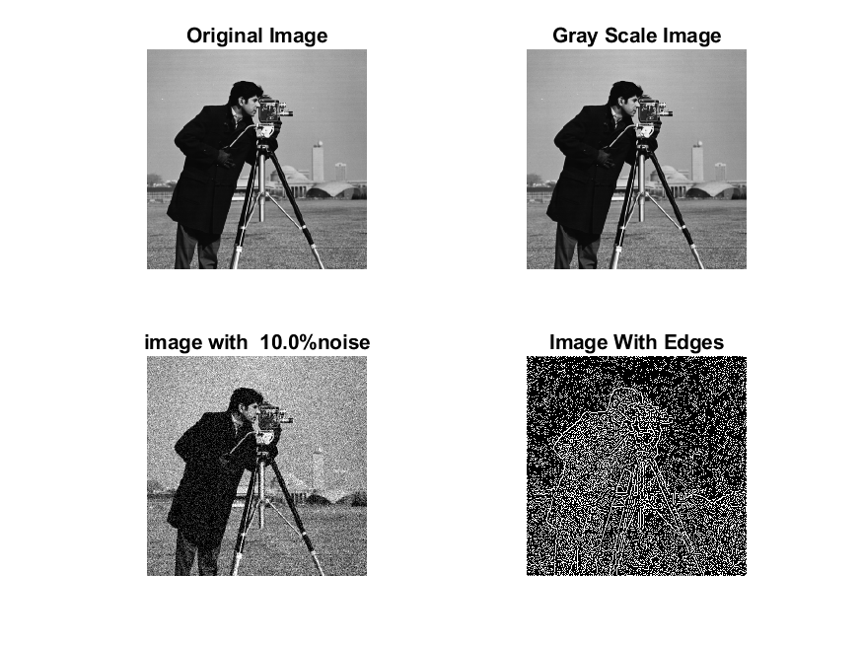

**Image 3:-20 % Noise**

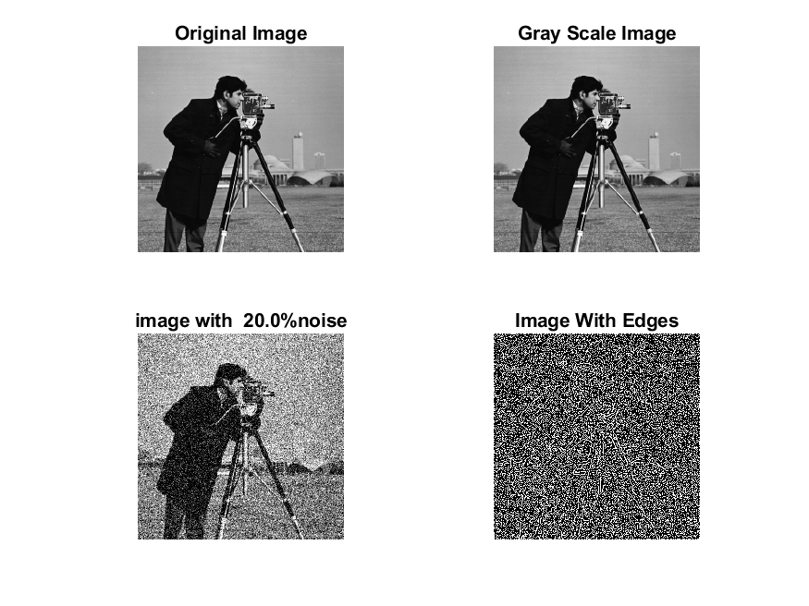

**Image 4:-30 % Noise**

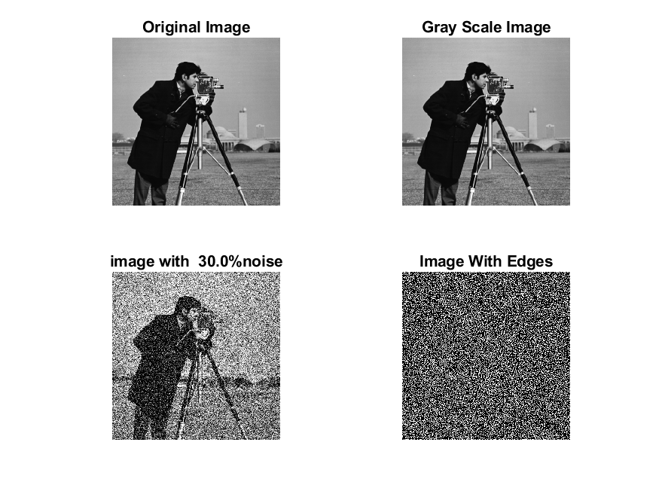

|  |
| --- |
| **Image 5:-40 % Noise** |

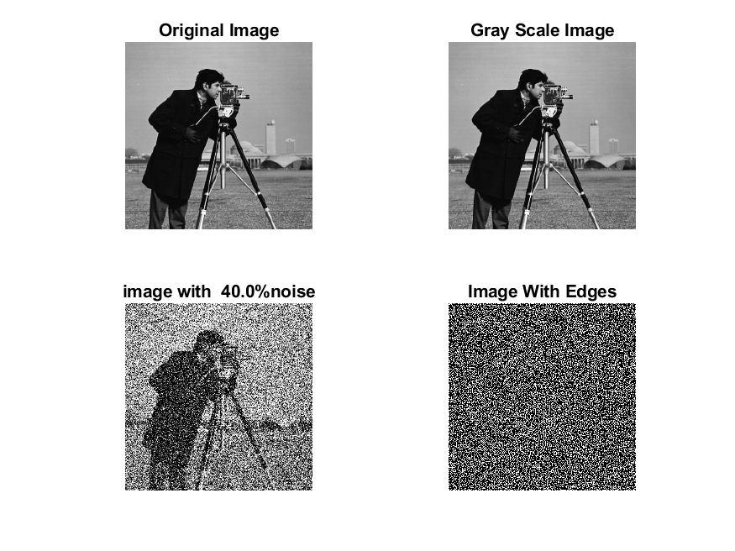

**Image 6:-50 % Noise**

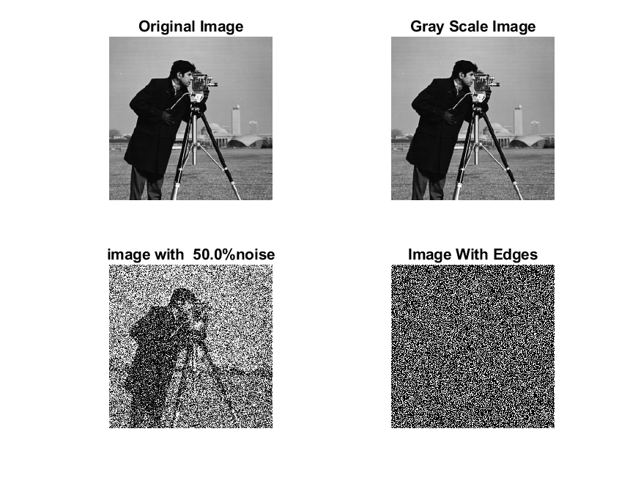

**Image 7:-60 % Noise**

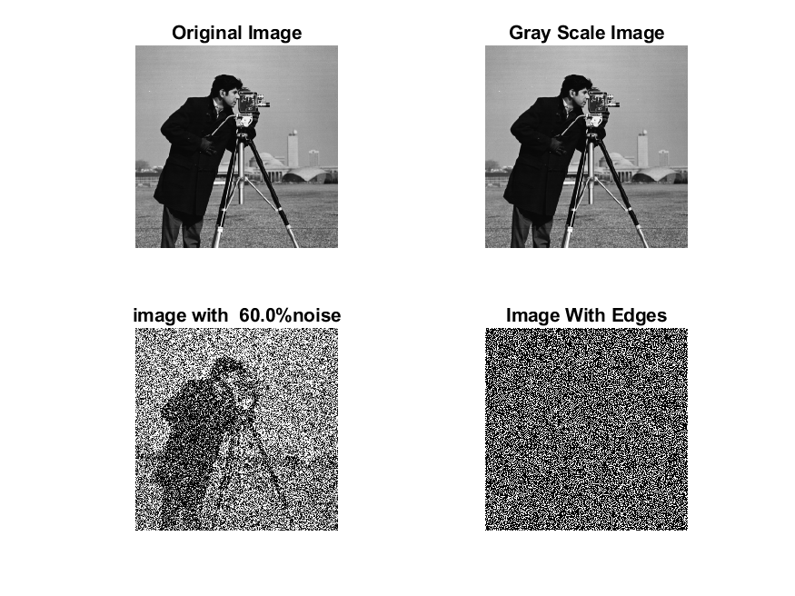

**Image 8:-70 % Noise**

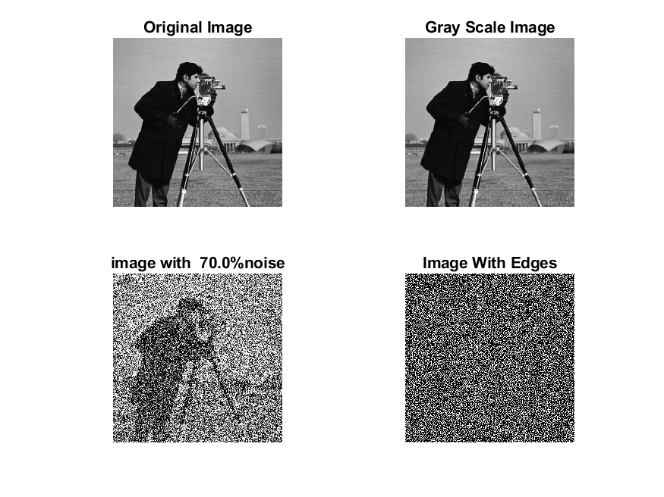

**Image 9:-80 % Noise**

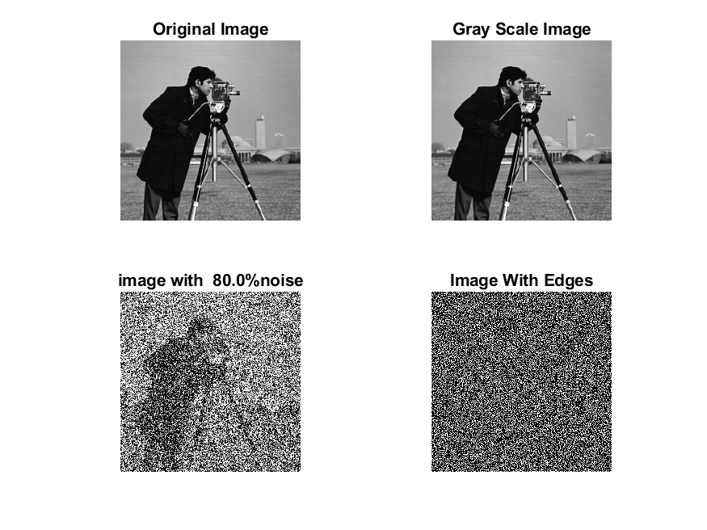

**DATA FILES**

**Image 1:-Noise0.1**

Original image ideal values:

IM1 image entropy:4.261362e-01

IM1 image mean:0.086929

Ground truth image entropy:0.717315

Ground truth image mean:0.197705

entropy between imt and im1 :0.656408

MSE between imt and im1 :0.228091

Average Difference between imt and im1 :0.110776

Maximum Difference between imt and im1 :1.000000

True Positive values:1444.000000

False Positive values: 2996.000000

True Negative values:37982.000000

False Negative values:8654.000000

Accuracy value: 0.771909

F Measure values:0.198652

Peak Signal-to Noise Ration value: 6.418910

Signal-to Noise Ration value: -3.568524

percentage of pixels that were correctly detected (Pco): 0.142999

The percentage of pixels that were not detected (Pnd):0.857001

the percentage of false alarm: (Pfa):0.296692

Euclidean Distance Value :13.358301

**Image 2:-Noise10**

Original image ideal values:

IM1 image entropy:8.278152e-01

IM1 image mean:0.260710

Ground truth image entropy:0.717315

Ground truth image mean:0.197705

entropy between imt and im1 :0.585282

MSE between imt and im1 :0.343801

Average Difference between imt and im1 :-0.063004

Maximum Difference between imt and im1 :1.000000

True Positive values:2927.000000

False Positive values: 10389.000000

True Negative values:30589.000000

False Negative values:7171.000000

Accuracy value: 0.656199

F Measure values:0.250021

Peak Signal-to Noise Ration value: 4.636924

Signal-to Noise Ration value: 1.201384

percentage of pixels that were correctly detected (Pco): 0.219811

The percentage of pixels that were not detected (Pnd):0.538525

the percentage of false alarm: (Pfa):0.780189

Euclidean Distance Value :21.023783

**Image 3:-Noise20**

Original image ideal values:

IM1 image entropy:9.139416e-01

IM1 image mean:0.329039

Ground truth image entropy:0.717315

Ground truth image mean:0.197705

entropy between imt and im1 :0.564065

MSE between imt and im1 :0.396194

Average Difference between imt and im1 :-0.131334

Maximum Difference between imt and im1 :1.000000

True Positive values:3334.000000

False Positive values: 13472.000000

True Negative values:27506.000000

False Negative values:6764.000000

Accuracy value: 0.603806

F Measure values:0.247844

Peak Signal-to Noise Ration value: 4.020922

Signal-to Noise Ration value: 2.212290

percentage of pixels that were correctly detected (Pco): 0.198382

The percentage of pixels that were not detected (Pnd):0.402475

the percentage of false alarm: (Pfa):0.801618

Euclidean Distance Value :18.880766

**Image 4:-Noise30**

Original image ideal values:

IM1 image entropy:9.180738e-01

IM1 image mean:0.333111

Ground truth image entropy:0.717315

Ground truth image mean:0.197705

entropy between imt and im1 :0.564490

MSE between imt and im1 :0.400580

Average Difference between imt and im1 :-0.135406

Maximum Difference between imt and im1 :1.000000

True Positive values:3326.000000

False Positive values: 13688.000000

True Negative values:27290.000000

False Negative values:6772.000000

Accuracy value: 0.599420

F Measure values:0.245353

Peak Signal-to Noise Ration value: 3.973112

Signal-to Noise Ration value: 2.265711

percentage of pixels that were correctly detected (Pco): 0.195486

The percentage of pixels that were not detected (Pnd):0.398025

the percentage of false alarm: (Pfa):0.804514

Euclidean Distance Value :18.593063

**Image 5:-Noise40**

Original image ideal values:

IM1 image entropy:9.221555e-01

IM1 image mean:0.337243

Ground truth image entropy:0.717315

Ground truth image mean:0.197705

entropy between imt and im1 :0.561511

MSE between imt and im1 :0.402518

Average Difference between imt and im1 :-0.139537

Maximum Difference between imt and im1 :1.000000

True Positive values:3382.000000

False Positive values: 13843.000000

True Negative values:27135.000000

False Negative values:6716.000000

Accuracy value: 0.597482

F Measure values:0.247557

Peak Signal-to Noise Ration value: 3.952149

Signal-to Noise Ration value: 2.319239

percentage of pixels that were correctly detected (Pco): 0.196343

The percentage of pixels that were not detected (Pnd):0.389898

the percentage of false alarm: (Pfa):0.803657

Euclidean Distance Value :18.678218

**Image 6:-Noise50**

Original image ideal values:

IM1 image entropy:9.239761e-01

IM1 image mean:0.339122

Ground truth image entropy:0.717315

Ground truth image mean:0.197705

entropy between imt and im1 :0.562151

MSE between imt and im1 :0.404867

Average Difference between imt and im1 :-0.141417

Maximum Difference between imt and im1 :1.000000

True Positive values:3370.000000

False Positive values: 13951.000000

True Negative values:27027.000000

False Negative values:6728.000000

Accuracy value: 0.595133

F Measure values:0.245815

Peak Signal-to Noise Ration value: 3.926873

Signal-to Noise Ration value: 2.343376

percentage of pixels that were correctly detected (Pco): 0.194562

The percentage of pixels that were not detected (Pnd):0.388430

the percentage of false alarm: (Pfa):0.805438

Euclidean Distance Value :18.500585

**Image 7:-Noise60**

Original image ideal values:

IM1 image entropy:9.288657e-01

IM1 image mean:0.344291

Ground truth image entropy:0.717315

Ground truth image mean:0.197705

entropy between imt and im1 :0.559053

MSE between imt and im1 :0.407765

Average Difference between imt and im1 :-0.146585

Maximum Difference between imt and im1 :1.000000

True Positive values:3428.000000

False Positive values: 14157.000000

True Negative values:26821.000000

False Negative values:6670.000000

Accuracy value: 0.592235

F Measure values:0.247661

Peak Signal-to Noise Ration value: 3.895902

Signal-to Noise Ration value: 2.409070

percentage of pixels that were correctly detected (Pco): 0.194939

The percentage of pixels that were not detected (Pnd):0.379301

the percentage of false alarm: (Pfa):0.805061

Euclidean Distance Value :18.537940

**Image 8:-Noise70**

Original image ideal values:

IM1 image entropy:9.304396e-01

IM1 image mean:0.345994

Ground truth image entropy:0.717315

Ground truth image mean:0.197705

entropy between imt and im1 :0.555778

MSE between imt and im1 :0.407080

Average Difference between imt and im1 :-0.148289

Maximum Difference between imt and im1 :1.000000

True Positive values:3489.000000

False Positive values: 14183.000000

True Negative values:26795.000000

False Negative values:6609.000000

Accuracy value: 0.592920

F Measure values:0.251278

Peak Signal-to Noise Ration value: 3.903206

Signal-to Noise Ration value: 2.430503

percentage of pixels that were correctly detected (Pco): 0.197431

The percentage of pixels that were not detected (Pnd):0.373981

the percentage of false alarm: (Pfa):0.802569

Euclidean Distance Value :18.786288

**Image 9:-Noise80**

Original image ideal values:

IM1 image entropy:9.299170e-01

IM1 image mean:0.345426

Ground truth image entropy:0.717315

Ground truth image mean:0.197705

entropy between imt and im1 :0.557606

MSE between imt and im1 :0.407843

Average Difference between imt and im1 :-0.147721

Maximum Difference between imt and im1 :1.000000

True Positive values:3455.000000

False Positive values: 14188.000000

True Negative values:26790.000000

False Negative values:6643.000000

Accuracy value: 0.592157

F Measure values:0.249090

Peak Signal-to Noise Ration value: 3.895068

Signal-to Noise Ration value: 2.423371

percentage of pixels that were correctly detected (Pco): 0.195828

The percentage of pixels that were not detected (Pnd):0.376523

the percentage of false alarm: (Pfa):0.804172

Euclidean Distance Value :18.626554